**PARTE 1**

Login y registro

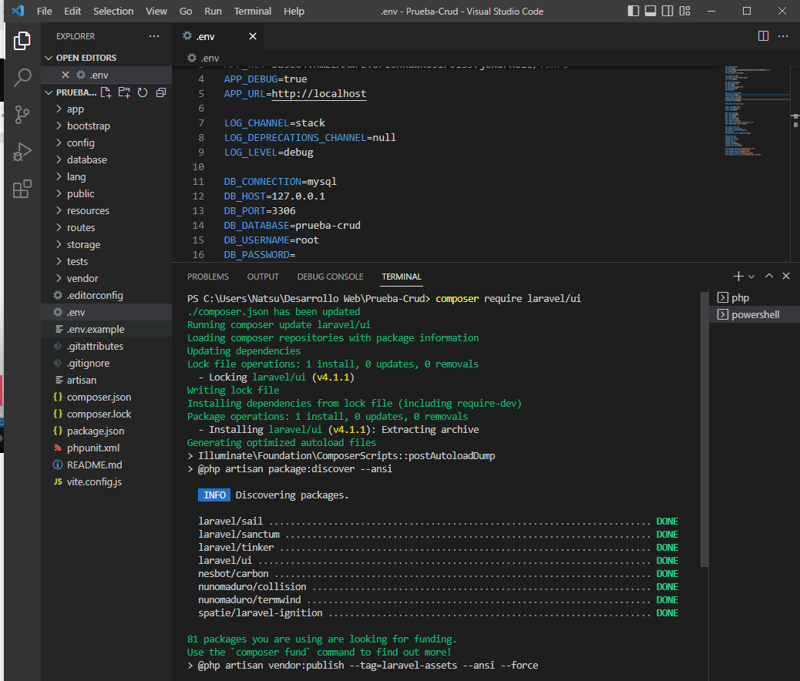

2

3

4

5

6

7

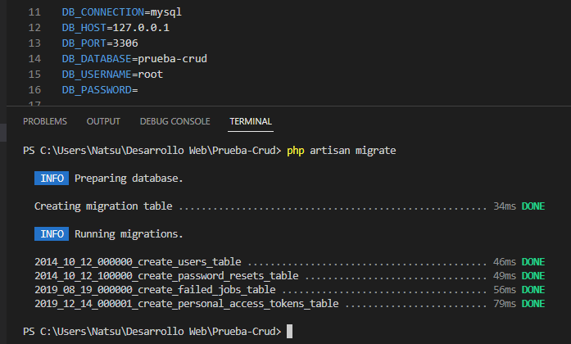

8

9

10

**PARTE 2**

CONFIGURACION

1

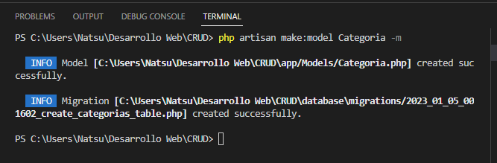

Creamos modelo con una tabla llamada categoría, y -m para crear una migración

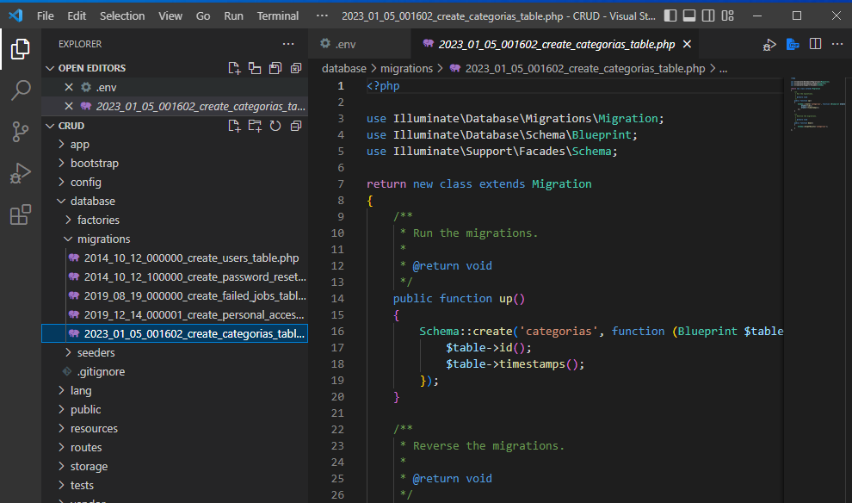

2

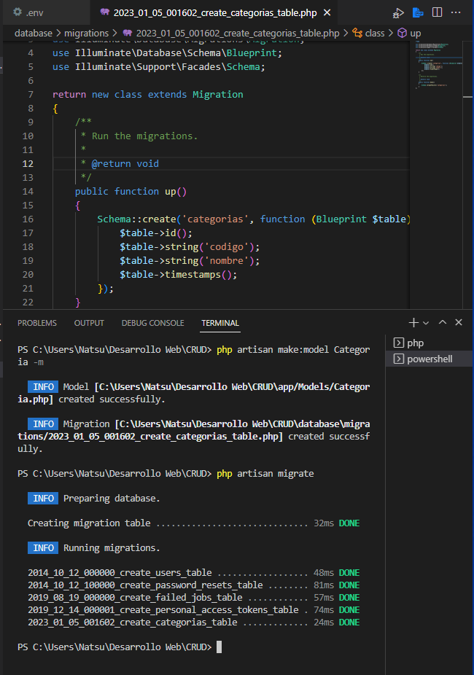

3

Creación del cotrolador con los distintos métodos (créate, read, update)

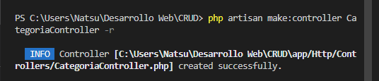

CREACION DE RUTAS, PRUEBAS AL CONTROLADOR

1

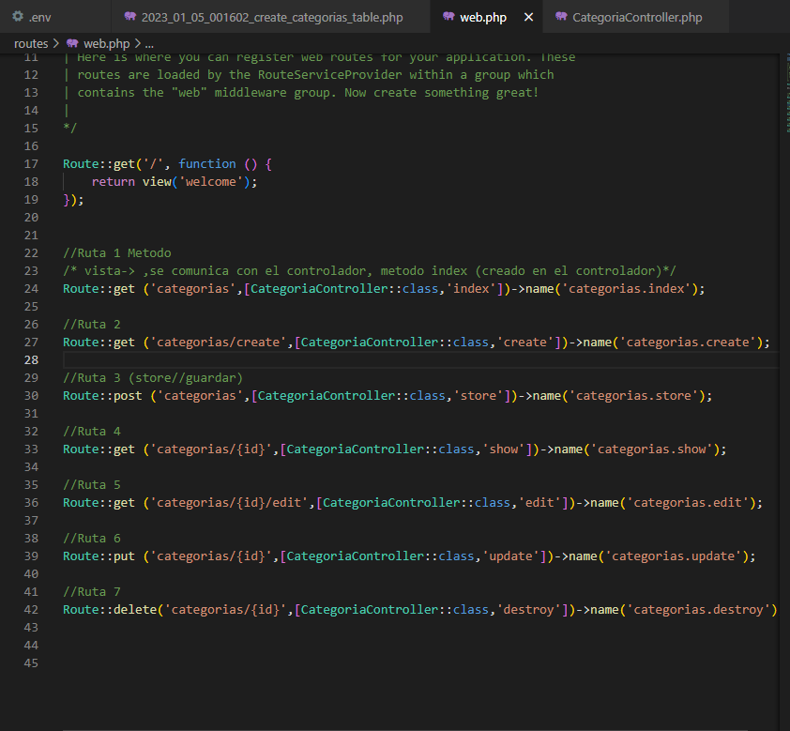

2 comprobamos que si se estén comunicando

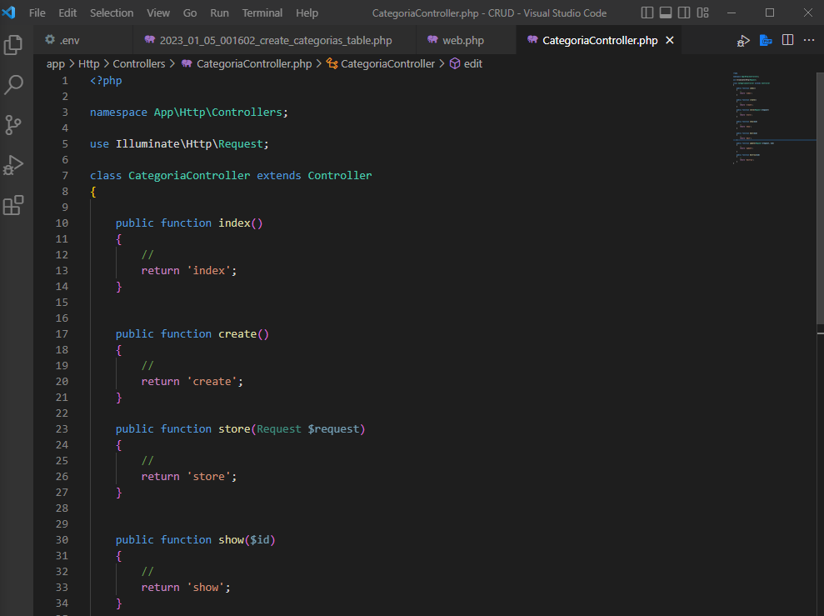

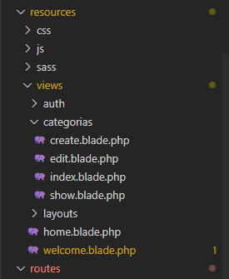

WELOCME PHP

            <div class="max-w-6xl mx-auto sm:px-6 lg:px-8">

                <div class="flex justify-center pt-8 sm:justify-start sm:pt-0">

                    <svg viewBox="0 0 651 192" fill="none" xmlns="http://www.w3.org/2000/svg" class="h-16 w-auto text-gray-700 sm:h-20">

                        <g clip-path="url(#clip0)" fill="#EF3B2D">

                            <path d="M248.032 44.676h-16.466v100.23h47.394v-14.748h-30.928V44.676zM337.091 87.202c-2.101-3.341-5.083-5.965-8.949-7.875-3.865-1.909-7.756-2.864-11.669-2.864-5.062 0-9.69.931-13.89 2.792-4.201 1.861-7.804 4.417-10.811 7.661-3.007 3.246-5.347 6.993-7.016 11.239-1.672 4.249-2.506 8.713-2.506 13.389 0 4.774.834 9.26 2.506 13.459 1.669 4.202 4.009 7.925 7.016 11.169 3.007 3.246 6.609 5.799 10.811 7.66 4.199 1.861 8.828 2.792 13.89 2.792 3.913 0 7.804-.955 11.669-2.863 3.866-1.908 6.849-4.533 8.949-7.875v9.021h15.607V78.182h-15.607v9.02zm-1.431 32.503c-.955 2.578-2.291 4.821-4.009 6.73-1.719 1.91-3.795 3.437-6.229 4.582-2.435 1.146-5.133 1.718-8.091 1.718-2.96 0-5.633-.572-8.019-1.718-2.387-1.146-4.438-2.672-6.156-4.582-1.719-1.909-3.032-4.152-3.938-6.73-.909-2.577-1.36-5.298-1.36-8.161 0-2.864.451-5.585 1.36-8.162.905-2.577 2.219-4.819 3.938-6.729 1.718-1.908 3.77-3.437 6.156-4.582 2.386-1.146 5.059-1.718 8.019-1.718 2.958 0 5.656.572 8.091 1.718 2.434 1.146 4.51 2.674 6.229 4.582 1.718 1.91 3.054 4.152 4.009 6.729.953 2.577 1.432 5.298 1.432 8.162-.001 2.863-.479 5.584-1.432 8.161zM463.954 87.202c-2.101-3.341-5.083-5.965-8.949-7.875-3.865-1.909-7.756-2.864-11.669-2.864-5.062 0-9.69.931-13.89 2.792-4.201 1.861-7.804 4.417-10.811 7.661-3.007 3.246-5.347 6.993-7.016 11.239-1.672 4.249-2.506 8.713-2.506 13.389 0 4.774.834 9.26 2.506 13.459 1.669 4.202 4.009 7.925 7.016 11.169 3.007 3.246 6.609 5.799 10.811 7.66 4.199 1.861 8.828 2.792 13.89 2.792 3.913 0 7.804-.955 11.669-2.863 3.866-1.908 6.849-4.533 8.949-7.875v9.021h15.607V78.182h-15.607v9.02zm-1.432 32.503c-.955 2.578-2.291 4.821-4.009 6.73-1.719 1.91-3.795 3.437-6.229 4.582-2.435 1.146-5.133 1.718-8.091 1.718-2.96 0-5.633-.572-8.019-1.718-2.387-1.146-4.438-2.672-6.156-4.582-1.719-1.909-3.032-4.152-3.938-6.73-.909-2.577-1.36-5.298-1.36-8.161 0-2.864.451-5.585 1.36-8.162.905-2.577 2.219-4.819 3.938-6.729 1.718-1.908 3.77-3.437 6.156-4.582 2.386-1.146 5.059-1.718 8.019-1.718 2.958 0 5.656.572 8.091 1.718 2.434 1.146 4.51 2.674 6.229 4.582 1.718 1.91 3.054 4.152 4.009 6.729.953 2.577 1.432 5.298 1.432 8.162 0 2.863-.479 5.584-1.432 8.161zM650.772 44.676h-15.606v100.23h15.606V44.676zM365.013 144.906h15.607V93.538h26.776V78.182h-42.383v66.724zM542.133 78.182l-19.616 51.096-19.616-51.096h-15.808l25.617 66.724h19.614l25.617-66.724h-15.808zM591.98 76.466c-19.112 0-34.239 15.706-34.239 35.079 0 21.416 14.641 35.079 36.239 35.079 12.088 0 19.806-4.622 29.234-14.688l-10.544-8.158c-.006.008-7.958 10.449-19.832 10.449-13.802 0-19.612-11.127-19.612-16.884h51.777c2.72-22.043-11.772-40.877-33.023-40.877zm-18.713 29.28c.12-1.284 1.917-16.884 18.589-16.884 16.671 0 18.697 15.598 18.813 16.884h-37.402zM184.068 43.892c-.024-.088-.073-.165-.104-.25-.058-.157-.108-.316-.191-.46-.056-.097-.137-.176-.203-.265-.087-.117-.161-.242-.265-.345-.085-.086-.194-.148-.29-.223-.109-.085-.206-.182-.327-.252l-.002-.001-.002-.002-35.648-20.524a2.971 2.971 0 00-2.964 0l-35.647 20.522-.002.002-.002.001c-.121.07-.219.167-.327.252-.096.075-.205.138-.29.223-.103.103-.178.228-.265.345-.066.089-.147.169-.203.265-.083.144-.133.304-.191.46-.031.085-.08.162-.104.25-.067.249-.103.51-.103.776v38.979l-29.706 17.103V24.493a3 3 0 00-.103-.776c-.024-.088-.073-.165-.104-.25-.058-.157-.108-.316-.191-.46-.056-.097-.137-.176-.203-.265-.087-.117-.161-.242-.265-.345-.085-.086-.194-.148-.29-.223-.109-.085-.206-.182-.327-.252l-.002-.001-.002-.002L40.098 1.396a2.971 2.971 0 00-2.964 0L1.487 21.919l-.002.002-.002.001c-.121.07-.219.167-.327.252-.096.075-.205.138-.29.223-.103.103-.178.228-.265.345-.066.089-.147.169-.203.265-.083.144-.133.304-.191.46-.031.085-.08.162-.104.25-.067.249-.103.51-.103.776v122.09c0 1.063.568 2.044 1.489 2.575l71.293 41.045c.156.089.324.143.49.202.078.028.15.074.23.095a2.98 2.98 0 001.524 0c.069-.018.132-.059.2-.083.176-.061.354-.119.519-.214l71.293-41.045a2.971 2.971 0 001.489-2.575v-38.979l34.158-19.666a2.971 2.971 0 001.489-2.575V44.666a3.075 3.075 0 00-.106-.774zM74.255 143.167l-29.648-16.779 31.136-17.926.001-.001 34.164-19.669 29.674 17.084-21.772 12.428-43.555 24.863zm68.329-76.259v33.841l-12.475-7.182-17.231-9.92V49.806l12.475 7.182 17.231 9.92zm2.97-39.335l29.693 17.095-29.693 17.095-29.693-17.095 29.693-17.095zM54.06 114.089l-12.475 7.182V46.733l17.231-9.92 12.475-7.182v74.537l-17.231 9.921zM38.614 7.398l29.693 17.095-29.693 17.095L8.921 24.493 38.614 7.398zM5.938 29.632l12.475 7.182 17.231 9.92v79.676l.001.005-.001.006c0 .114.032.221.045.333.017.146.021.294.059.434l.002.007c.032.117.094.222.14.334.051.124.088.255.156.371a.036.036 0 00.004.009c.061.105.149.191.222.288.081.105.149.22.244.314l.008.01c.084.083.19.142.284.215.106.083.202.178.32.247l.013.005.011.008 34.139 19.321v34.175L5.939 144.867V29.632h-.001zm136.646 115.235l-65.352 37.625V148.31l48.399-27.628 16.953-9.677v33.862zm35.646-61.22l-29.706 17.102V66.908l17.231-9.92 12.475-7.182v33.841z"/>

                        </g>

                    </svg>

                </div>

                <div class="mt-8 bg-white dark:bg-gray-800 overflow-hidden shadow sm:rounded-lg">

                    <div class="grid grid-cols-1 md:grid-cols-2">

                        <div class="p-6">

                            <div class="flex items-center">

                                <svg xmlns="http://www.w3.org/2000/svg" fill="none" viewBox="0 0 24 24" stroke-width="1.5" stroke="currentColor" class="w-8 h-8 text-gray-500"><path stroke-linecap="round" stroke-linejoin="round" d="M12 6.042A8.967 8.967 0 006 3.75c-1.052 0-2.062.18-3 .512v14.25A8.987 8.987 0 016 18c2.305 0 4.408.867 6 2.292m0-14.25a8.966 8.966 0 016-2.292c1.052 0 2.062.18 3 .512v14.25A8.987 8.987 0 0018 18a8.967 8.967 0 00-6 2.292m0-14.25v14.25" /></svg>

                                <div class="ml-4 text-lg leading-7 font-semibold"><a href="https://laravel.com/docs" class="underline text-gray-900 dark:text-white">Documentation</a></div>

                            </div>

                            <div class="ml-12">

                                <div class="mt-2 text-gray-600 dark:text-gray-400 text-sm">

                                    aaaaa Laravel has wonderful, thorough documentation covering every aspect of the framework. Whether you are new to the framework or have previous experience with Laravel, we recommend reading all of the documentation from beginning to end.

                                </div>

                            </div>

                        </div>

                        <div class="p-6 border-t border-gray-200 dark:border-gray-700 md:border-t-0 md:border-l">

                            <div class="flex items-center">

                                <svg xmlns="http://www.w3.org/2000/svg" fill="none" viewBox="0 0 24 24" stroke-width="1.5" stroke="currentColor" class="w-8 h-8 text-gray-500"><path stroke-linecap="round" d="M15.75 10.5l4.72-4.72a.75.75 0 011.28.53v11.38a.75.75 0 01-1.28.53l-4.72-4.72M4.5 18.75h9a2.25 2.25 0 002.25-2.25v-9a2.25 2.25 0 00-2.25-2.25h-9A2.25 2.25 0 002.25 7.5v9a2.25 2.25 0 002.25 2.25z" /></svg>

                                <div class="ml-4 text-lg leading-7 font-semibold"><a href="https://laracasts.com" class="underline text-gray-900 dark:text-white">Laracasts</a></div>

                            </div>

                            <div class="ml-12">

                                <div class="mt-2 text-gray-600 dark:text-gray-400 text-sm">

                                    Laracasts offers thousands of video tutorials on Laravel, PHP, and JavaScript development. Check them out, see for yourself, and massively level up your development skills in the process.

                                </div>

                            </div>

                        </div>

                        <div class="p-6 border-t border-gray-200 dark:border-gray-700">

                            <div class="flex items-center">

                                <svg xmlns="http://www.w3.org/2000/svg" fill="none" viewBox="0 0 24 24" stroke-width="1.5" stroke="currentColor" class="w-8 h-8 text-gray-500"><path stroke-linecap="round" stroke-linejoin="round" d="M7.5 8.25h9m-9 3H12m-9.75 1.51c0 1.6 1.123 2.994 2.707 3.227 1.129.166 2.27.293 3.423.379.35.026.67.21.865.501L12 21l2.755-4.133a1.14 1.14 0 01.865-.501 48.172 48.172 0 003.423-.379c1.584-.233 2.707-1.626 2.707-3.228V6.741c0-1.602-1.123-2.995-2.707-3.228A48.394 48.394 0 0012 3c-2.392 0-4.744.175-7.043.513C3.373 3.746 2.25 5.14 2.25 6.741v6.018z" /></svg>

                                <div class="ml-4 text-lg leading-7 font-semibold"><a href="https://laravel-news.com/" class="underline text-gray-900 dark:text-white">Laravel News</a></div>

                            </div>

                            <div class="ml-12">

                                <div class="mt-2 text-gray-600 dark:text-gray-400 text-sm">

                                    Laravel News is a community driven portal and newsletter aggregating all of the latest and most important news in the Laravel ecosystem, including new package releases and tutorials.

                                </div>

                            </div>

                        </div>

                        <div class="p-6 border-t border-gray-200 dark:border-gray-700 md:border-l">

                            <div class="flex items-center">

                                <svg xmlns="http://www.w3.org/2000/svg" fill="none" viewBox="0 0 24 24" stroke-width="1.5" stroke="currentColor" class="w-8 h-8 text-gray-500"><path stroke-linecap="round" stroke-linejoin="round" d="M6.115 5.19l.319 1.913A6 6 0 008.11 10.36L9.75 12l-.387.775c-.217.433-.132.956.21 1.298l1.348 1.348c.21.21.329.497.329.795v1.089c0 .426.24.815.622 1.006l.153.076c.433.217.956.132 1.298-.21l.723-.723a8.7 8.7 0 002.288-4.042 1.087 1.087 0 00-.358-1.099l-1.33-1.108c-.251-.21-.582-.299-.905-.245l-1.17.195a1.125 1.125 0 01-.98-.314l-.295-.295a1.125 1.125 0 010-1.591l.13-.132a1.125 1.125 0 011.3-.21l.603.302a.809.809 0 001.086-1.086L14.25 7.5l1.256-.837a4.5 4.5 0 001.528-1.732l.146-.292M6.115 5.19A9 9 0 1017.18 4.64M6.115 5.19A8.965 8.965 0 0112 3c1.929 0 3.716.607 5.18 1.64" /></svg>

                                <div class="ml-4 text-lg leading-7 font-semibold text-gray-900 dark:text-white">Vibrant Ecosystem</div>

                            </div>

                            <div class="ml-12">

                                <div class="mt-2 text-gray-600 dark:text-gray-400 text-sm">

                                    Laravel's robust library of first-party tools and libraries, such as <a href="https://forge.laravel.com" class="underline">Forge</a>, <a href="https://vapor.laravel.com" class="underline">Vapor</a>, <a href="https://nova.laravel.com" class="underline">Nova</a>, and <a href="https://envoyer.io" class="underline">Envoyer</a> help you take your projects to the next level. Pair them with powerful open source libraries like <a href="https://laravel.com/docs/billing" class="underline">Cashier</a>, <a href="https://laravel.com/docs/dusk" class="underline">Dusk</a>, <a href="https://laravel.com/docs/broadcasting" class="underline">Echo</a>, <a href="https://laravel.com/docs/horizon" class="underline">Horizon</a>, <a href="https://laravel.com/docs/sanctum" class="underline">Sanctum</a>, <a href="https://laravel.com/docs/telescope" class="underline">Telescope</a>, and more.

                                </div>

                            </div>

                        </div>

                    </div>

                </div>

                <div class="flex justify-center mt-4 sm:items-center sm:justify-between">

                    <div class="text-center text-sm text-gray-500 sm:text-left">

                        <div class="flex items-center">

                            <svg xmlns="http://www.w3.org/2000/svg" fill="none" viewBox="0 0 24 24" stroke-width="1.5" stroke="currentColor" class="-mt-px w-5 h-5 text-gray-400">

                                <path stroke-linecap="round" stroke-linejoin="round" d="M2.25 3h1.386c.51 0 .955.343 1.087.835l.383 1.437M7.5 14.25a3 3 0 00-3 3h15.75m-12.75-3h11.218c1.121-2.3 2.1-4.684 2.924-7.138a60.114 60.114 0 00-16.536-1.84M7.5 14.25L5.106 5.272M6 20.25a.75.75 0 11-1.5 0 .75.75 0 011.5 0zm12.75 0a.75.75 0 11-1.5 0 .75.75 0 011.5 0z" />

                            </svg>

                            <a href="https://laravel.bigcartel.com" class="ml-1 underline">

                                Shop

                            </a>

                            <svg xmlns="http://www.w3.org/2000/svg" fill="none" viewBox="0 0 24 24" stroke-width="1.5" stroke="currentColor" class="ml-4 -mt-px w-5 h-5 text-gray-400">

                                <path stroke-linecap="round" stroke-linejoin="round" d="M21 8.25c0-2.485-2.099-4.5-4.688-4.5-1.935 0-3.597 1.126-4.312 2.733-.715-1.607-2.377-2.733-4.313-2.733C5.1 3.75 3 5.765 3 8.25c0 7.22 9 12 9 12s9-4.78 9-12z" />

                            </svg>

                            <a href="https://github.com/sponsors/taylorotwell" class="ml-1 underline">

                                Sponsor

                            </a>

                        </div>

                    </div>

                    <div class="ml-4 text-center text-sm text-gray-500 sm:text-right sm:ml-0">

                        Laravel v{{ Illuminate\Foundation\Application::VERSION }} (PHP v{{ PHP_VERSION }})

                    </div>

                </div>

            </div>